Assignment 9.2

**Explain the working of below pig script commands with an example :**

1. **LOAD**

Load data from the file system.

*Syntax:*

LOAD 'data' [USING function] [AS schema];

For Example,



1. **STORE**

Store data in the file system.

*Syntax:*

STORE alias INTO 'directory' [USING function];

For Example,

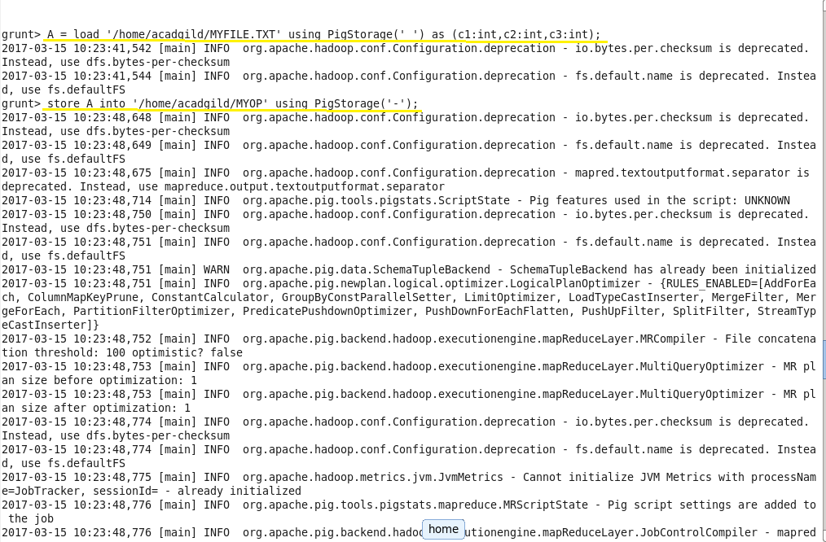

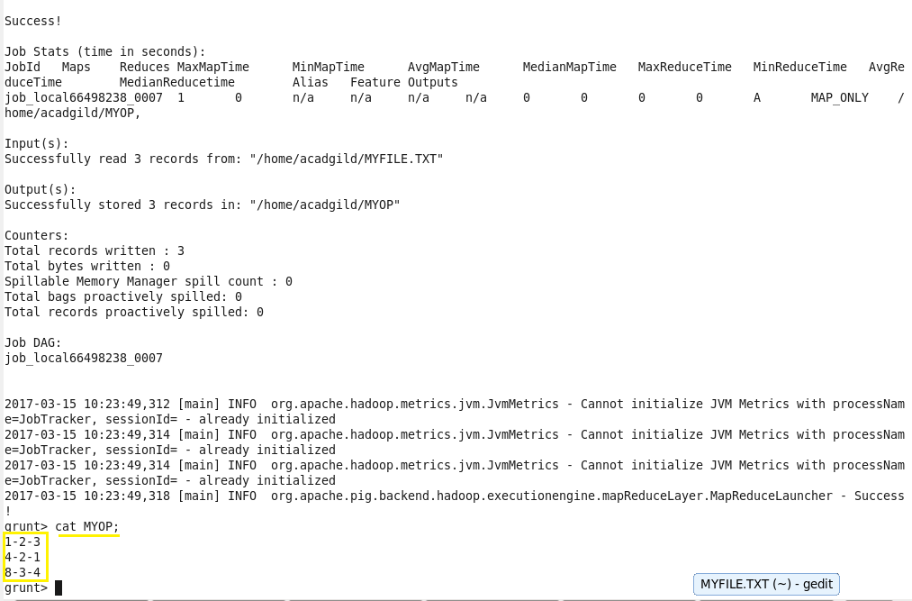

1. **DUMP**

Display results on screen.

*Syntax:*

DUMP alias;

For Example,

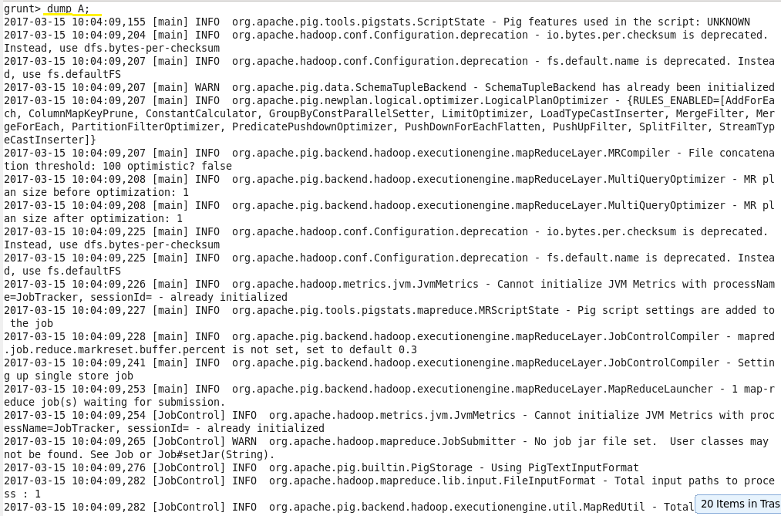

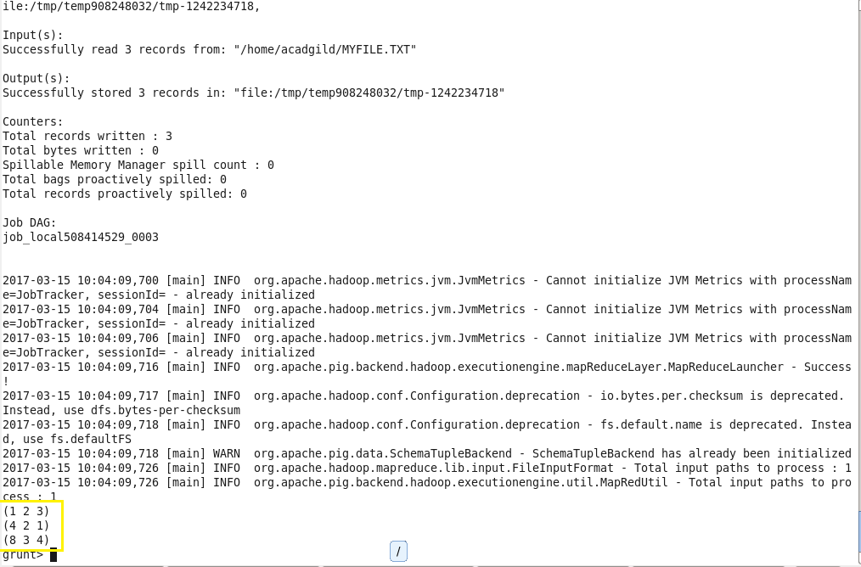

1. **FOREACH**

Iterate the tuples of a relation, generating a data transformation.

*Syntax:*

alias = FOREACH generate_operations [AS schema];

For Example,

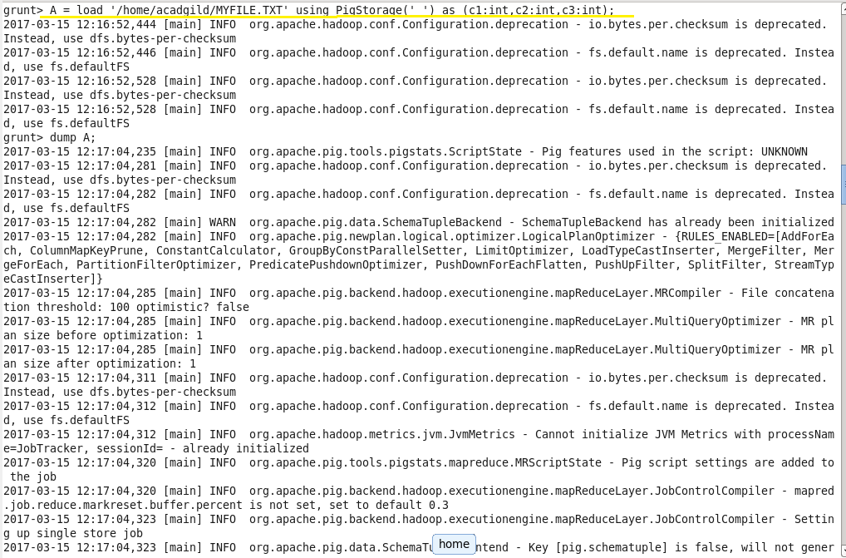

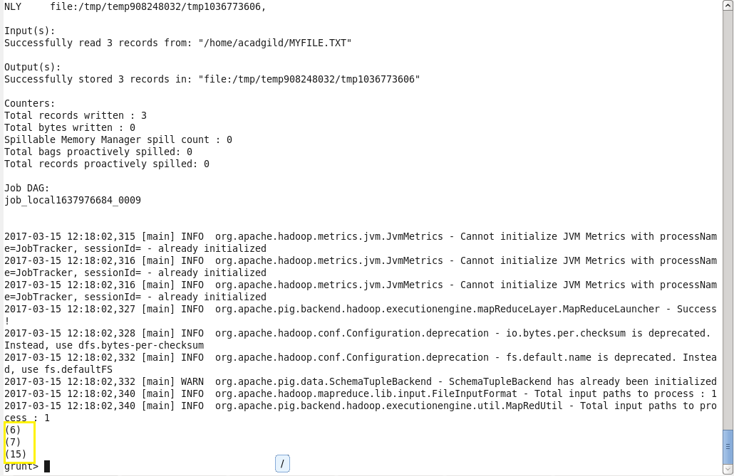

1. **FILTER**

Select a set of tuples from a relation based on a condition.

*Syntax:*

alias = FILTER alias BY expression;

For Example,

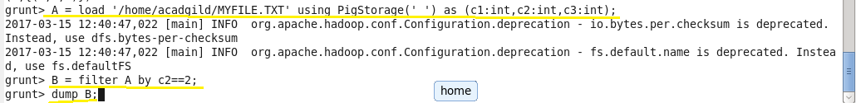

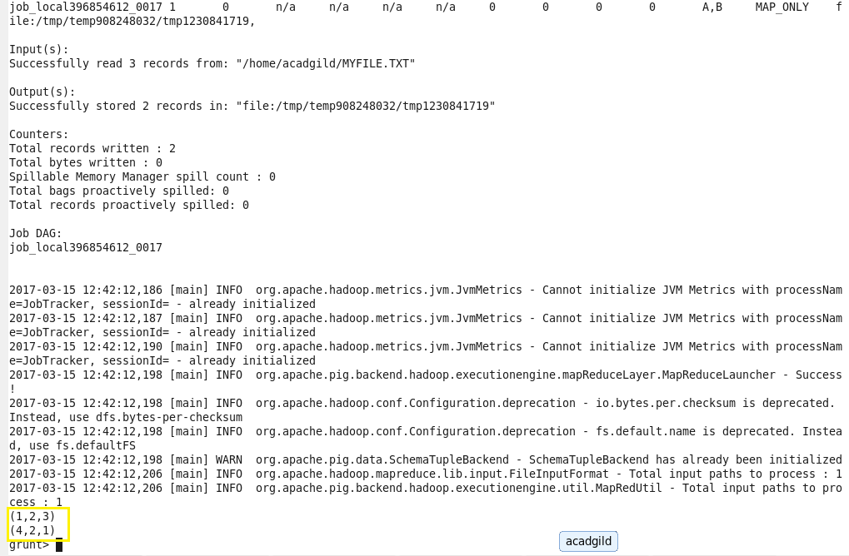

1. **GROUP BY**

Group the data in one or more relations.

*Syntax:*

alias = GROUP alias { ALL | BY expression} [, alias ALL | BY expression …] [PARALLEL n];

For Example,

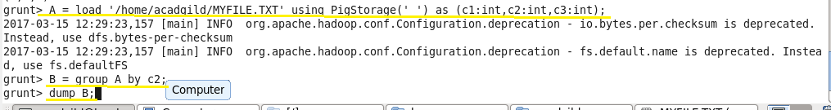

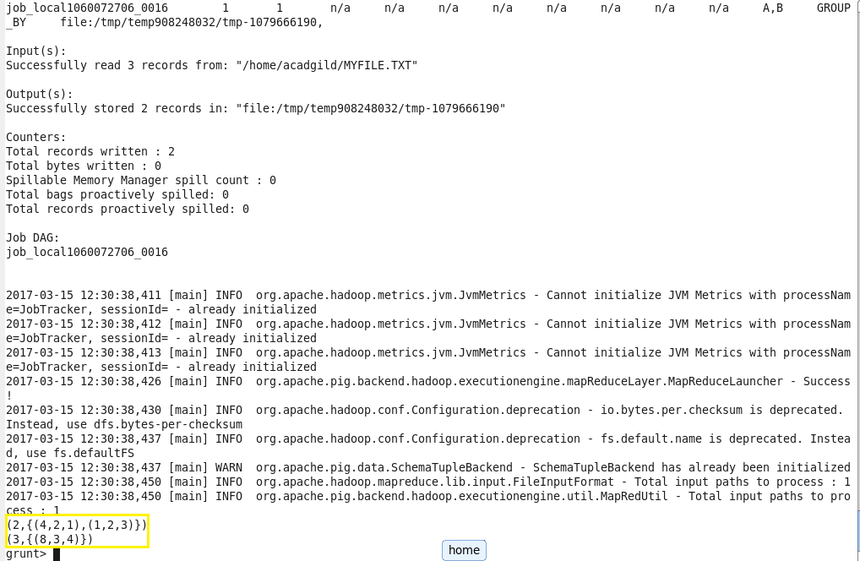

1. **ORDER BY**

Sort a relation based on one or more fields.

*Syntax:*

alias = ORDER alias BY { * [ASC|DESC] | field_alias [ASC|DESC] [, field_alias [ASC|DESC] …] } [PARALLEL];

For Example,

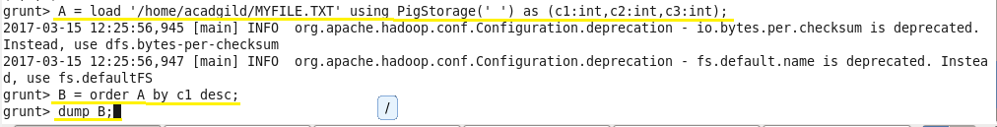

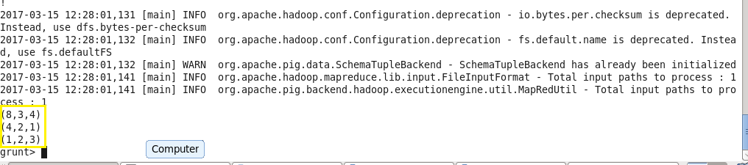

1. **DESCRIBE**

Returns the schema of an alias.

*Syntax:*

DESCRIBE alias;

For Example,

